
FT/PSQP/1223/A 08-JUN-2023
FIRST TERM EXAMINATION (2023-24)
Subject: GEOGRAPHY  Grade: XII |  | Max. Marks: 70  Time: 3 Hours
GENERAL INSTRUCTIONS-
I. Question paper is divided into 5 sections A ,B,C,D&E
II. In section A question number 1 to 17 are objective type questions.
III. In section B question 18 and 19 are Source based questions.
IV. In section C question number 20 to 23 are Short Answer based questions.
V. In section D question number 24 to 28 are Long Answer based questions.
VI .In section E question number 29 is a Map based question.
SECTION A
(OBJECTIVE TYPE QUESTIONS)
1. | Which one of the following Union Territories has the highest density of population? |  | 1
 | (a) NCT Delhi | (b) Andaman and Nicobar Island
 | (c) Chandigarh | (d) Puducherry
2 | The period from 1901 to 1921 is referred to as period of : |  | 1
 | (a) stagnant or stationary phase of growth of India’s population. | (b) steady population growth.
 | (c) population explosion in India . | (d) None of the Above
3. | Panna, Para, Palli, Nagla and Dhani are examples of: |  | 1
 | (a) clustered settlement
 | (b) hamleted settlement
 | (c) compact settlement
 | (d) dispersed settlement
4. | Varanasi, Mathura, Amritsar, Madurai, Puri are : |  | 1
 | (a) mining towns | (b) commercial towns
 | (c) religious towns | (d) heritage town
5 | Which one of the following states has the highest ground water utilization ? |  | 1
 | (a) Kerala | b) Andhra Pradesh
 | (c) Karnataka | (d) Tamil Nadu

6 | Arrange the following categories of towns in a sequence order according to their development in India:  - Ancient towns  - Ultra-modern towns  - (Metropolitans  - Modern towns |  | 1
 | Options: (a)i, iv, iii, ii
 | (b) iv, i, iii, ii
 | (c) ii, iv, i, iiii
 | (d) iii, ii, iv, i
7 | Which one of the following rivers has the highest replenishable ground water resource in the country? |  | 1
 | (a) The Indus | (b) The Brahmaputra
 | (c) The Ganga | (d) The Godavari
8 | The highest proportion of the total water used in the country is in which one of the following sectors? |  | 1
 | (a) Irrigation | (b) Industries
 | (c) Domestic use | (d) None of the above
9 | _________makes people vulnerable to drug abuse, alcoholism, crime, vandalism, escapism, apathy and ultimately social exclusion. |  | 1
 | (a) Crime | (b) Criticism
 | (c) adrenal rush | (d) Poverty
10 | The Swachh Bharat Mission was launched in: |  | 1
 | (a) 2014 | (b) 2015
 | (c) 2016 | (d) 2017
11. | ‘Urban waste disposal is a serious problem in India.’ Suggest measures that we as citizens can take to solve this problem of urban waste |  | 1
(a) Proper waste disposal bins provided by the municipality
(b) Segregate the wet and dry waste
(c) fines can be issued for not disposing waste in the required manner
(d) All of the Above
12. | The concept of human development was introduced by: |  | 1
 | (a) Dr. Mahbub-ul-Haq | (b) Nelson Mandela
 | (c) (Mao Zedong | (d) Winston Churchill
13 | ____________ measures the shortfall in human development. |  | 1
 | (a) Human development index | (b) Human development index
 | (c )Poverty index | (d) Happiness Index
14. | What is very high score for in Human development index? |  | 1
 | (a)above 0.6 | (b)above 0.7
 | (c) above 0.8 | (d)above 0.9
15. | Which country ranks first in Human development Index? |  | 1
 | (a)Norway | (b)Australia
 | (c)Iceland | (d)Canada1
16. | Which one of the following is a Rabi crop? |  | 1
 | (a)Rice | (b)Cotton
 | (c)Wheat | (d)Maize
17. | Which one of the following is NOT a land use category? |  | 1
 | (a)Fallow land | (b)Net Area Sown
 | (c)Marginal Land | (d)Culturable Wasteland
SECTION B
SOURCE BASED QUESTION
18 | Read the case study given below and answer the questions that follow:  Growth of population is the change in the number of people living in a particular area between two points of time. Its rate is expressed in percentage. Population growth has two components namely; natural and induced. While the natural growth is analysed by assessing the crude birth and death rates, the induced components are explained by the volume of inward and outward movement of people in any given area. The decadal and annual growth rates of population in India are both very high and steadily increasing over time. The annual growth rate of India’s population is 1.64 percent (2011). The growth rate of population in India over the last one century has been caused by annual birth rate and death rate and rate of migration and thereby shows different trends.
18.1 | How is the growth of population expressed? |  | 1
18.2 | Define natural growth of population. |  | 1
18.3 | What was the annual growth rate of India as per 2011 Census? |  | 1
19 | Read the case study given below and answer the questions that follow:
 | “…. Buses merely skirt the periphery. Auto rickshaws cannot go there, Dharavi is part of central Mumbai where three wheelers are banned. Only one main road traverses the slum, the miscalled ‘ninety-foot road’, which has been reduced to less than half of that for most of its length. The whole neighbourhood consists of temporary buildings, where a single room is rented by a whole family, sometimes accommodating twelve or more people; it is a kind of tropical version of the industrial dwelling of Victorian London’s East End. But Dharavi is a keeper of more sombre secrets than the revulsion it inspires in the rich. In this place of shadow less, uncollected garbage, stagnant pools of foul water, where the only non- human creatures are the shining black crows and long grey rats, some of the most beautiful, valuable and useful articles in India are made. From Dharavi come delicate ceramics and pottery, exquisite embroidery and Zari work, sophisticated leather goods, high-fashion garments, finely-wrought metalwork, delicate jewellery settings that would find its way into the richest houses, both in India and abroad. Dharavi was an arm of the sea, that was filled by waste, largely produced by the people who have come to live there: Scheduled Castes and poor Muslims
19.1 | In which state is Dharavi located? |  | 1
19.2 | To which place has Dharavi been compared to? |  | 1
19.3 | According to the passage, earlier Dharavi was a/an _________ of the sea? |  | 1
SECTION C
SHORT ANSWERS
20. | Examine three reasons for deterioration of water quality in India. |  | 3
21. | What are common property resources? Explain. |  | 3
22. | What are garrison towns? Name any two such towns. |  | 3
23. | Explain with examples the factors which determines the pattern of the population distribution in India. |  | 3
SECTION D
LONG ANSWERS
24. | Analyze the reasons why is the demand of water irrigation day by day increasing in India? Give three reasons.  What are the water conservation projects of Andhra Pradesh and Rajasthan? |  | 3+2
25.1 | Examine and explain the approaches to Human Development. |  | 5
 | OR
25.2 | What is the basic goal of human development? Elucidate the four Pillars of Human Development |  | 1+4
26.1 | Describe the uneven distribution of rural population in India. |  | 1+4
 | OR
26.2 | What do you mean by population growth?  Name the four language families in India .In which states this language is mainly spoken.  Which one of them is spoken by the largest number of people in the country? |  | 1+3+1
27. | Explain the four types of rural settlements found in India siting examples |  | 5
28. | Explain any four major problems associated with urban waste disposal in India. |  | 5
29 | SECTION - E  MAP QUESTIONS
29.1 | Identify the following on the political map of the world.  A.A major area of subsistence farming  B. A major area of nomadic herding  C. An area of commercial livestock rearing.  D. An area of extensive commercial grain farming  E. An area of Primitive agriculture |  | 5
29.2 | On the outline map of India indicate and mark the following features (any 5)  1)State with highest population density (2011)  2) state with lowest population density (2011)  Leading producing states of the following crops:  3) Rice  4) Tea  5) Cotton  6) Jute  1x5=5  Name: Roll No: Class/Section: |  | 5
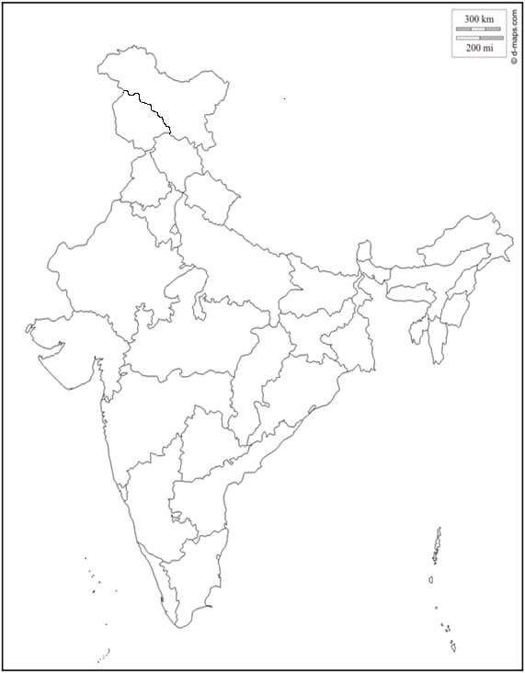

ROLL NO:
CLASS:
